

**CSE 326 CA3**

**Project Report**

**Project Title- ‘A Blog Website’**

**Group Members:-**

1. **Aayush Deep**

Registration No.- 12019059

Roll no.- RK20YRB61

Section- K20YR

1. **Sidharth Kumar**

Registration No.- 12019073

Roll no.- RK20YRB60

Section- K20YR

**Supervised By:-** Nahita Pathania Mam

**Submission Date:-** 06th May, 2021

**Introduction To Project**

Hello everyone,

Our group is very glad to present our academic skills in the form of the group project work which directed us to make a website named as **‘The Blog Website’** . As we know that a **blog** is a website where a person writes regularly about topics that interest them, usually with photographs and links to other websites they find interesting. There are many renowned Indian as well as International Blog Websites where we can see the most famous writers and authors too expressing their thoughts, ideas and enlightening certain topics that actually becomes the ‘Talk of the Town’ and gathers as many readers as possible.

So by exploring our project report you will be able to gather upon the basic idea of what a blog website actually look like. The making of the project helped us a lot in exploring the world of blogs. The website is well designed and carved by the skills of coding in the areas of HTML and CSS taught by our respected teacher Nahita Pathania Mam. We have tried our best to show up our html and css skills by using as many tags and attributes as possible. We have also inserted the images for its fascinating layout to attract the readers and have further attached some latest trending articles of current times. The website contains a ‘Login page’ where the user can log in and become a regular reader, the ‘Contact page’ refers to every way possible that you can use to contact the developers of the website and at last of the ‘Home page’ of the website we have attached a link that will directly take you the ‘Feedback Form’ fill up where we expect your valuable comments to help us improve better.

Further this report contains all the list of the tags that have been used by us to create this website followed by the ‘Snapshots’ of the output that will give the preview best possible of our website and at last the ‘Link’ to jump directly onto the website has been attached.

**List of ‘Tags’ that had been used in making of the ‘Website’**

**HTML**

<html> <head>

<title> <style>

<body> <h1>

<hr> <a>

<img> <marquee>

<div> <u>

<br> <p>

<ol> <li>

<ul> <center>

<form> <label>

<input> <select>

<option> <textarea>

<table> <th>

<tr> <td>

**CSS**

Padding cursor

class target

id name

display box-sizing

grid-template-columns height

grid-template-rows width

grip-gap float

border-radius clear

border font-family

font-size linear-gradient

color background-size

hover background-position

background-color transition

background-image text-align

margin text-decoration

**Snapshots of the Output**

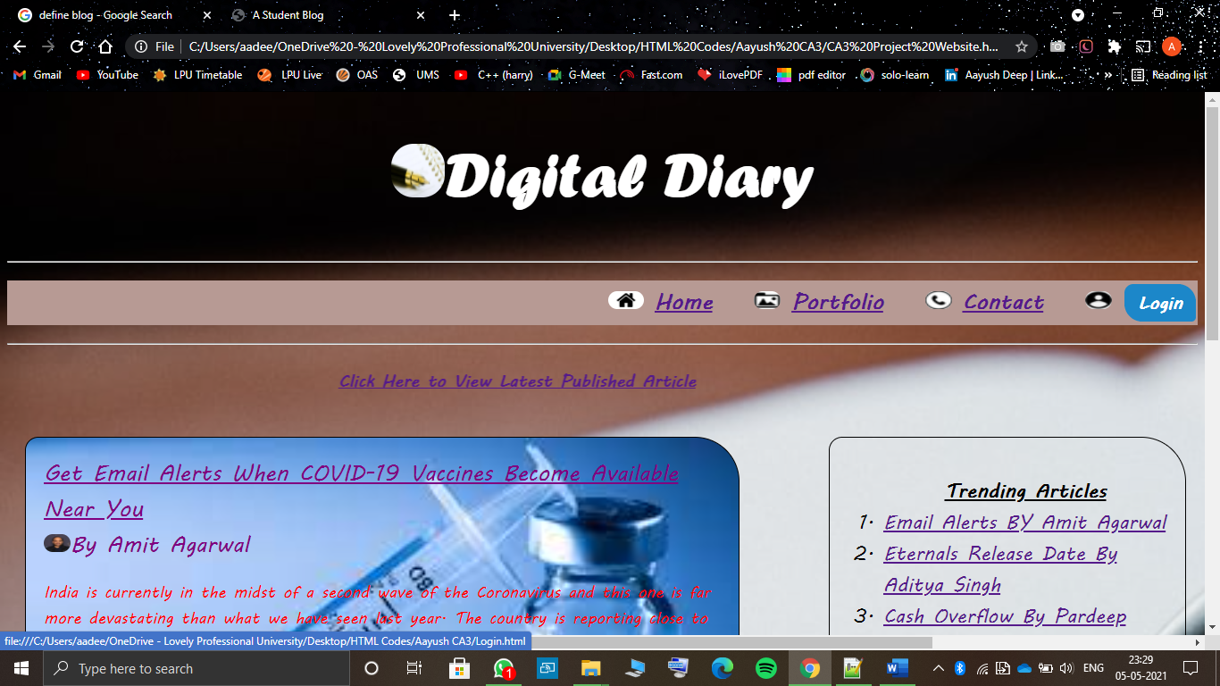

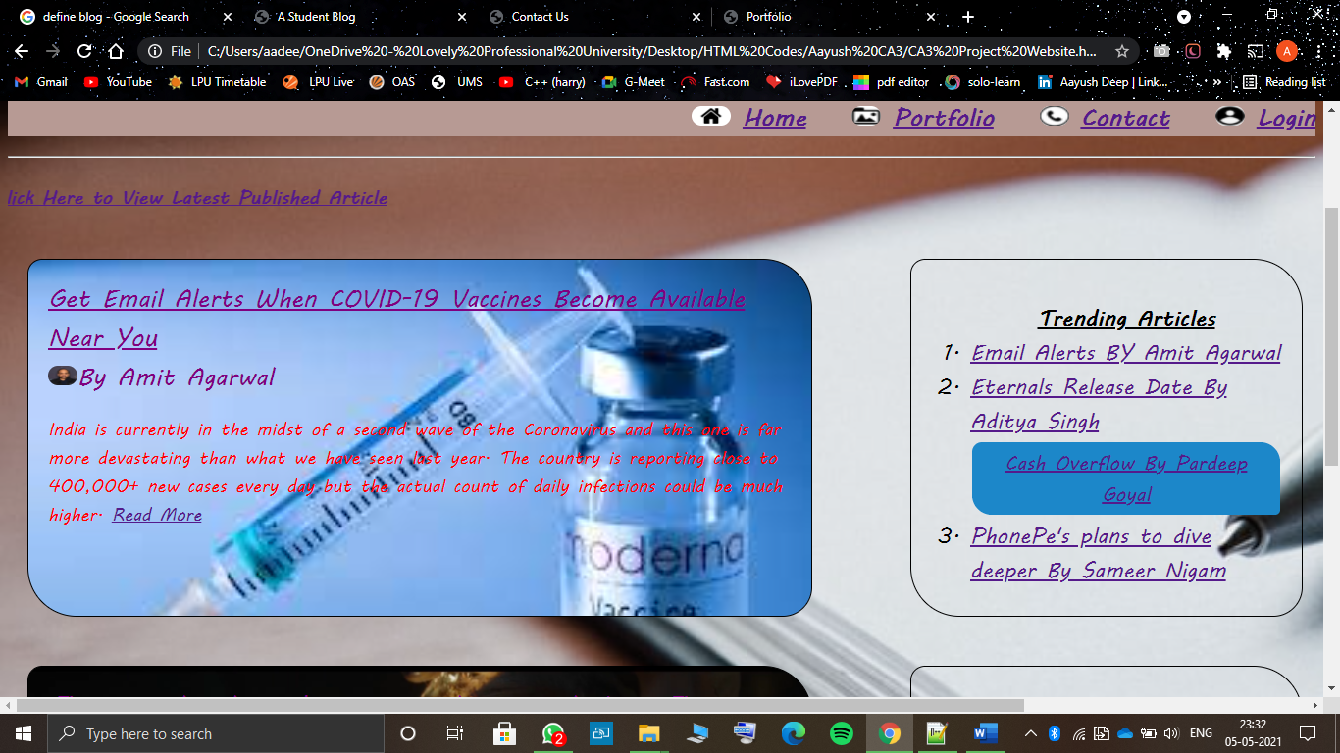

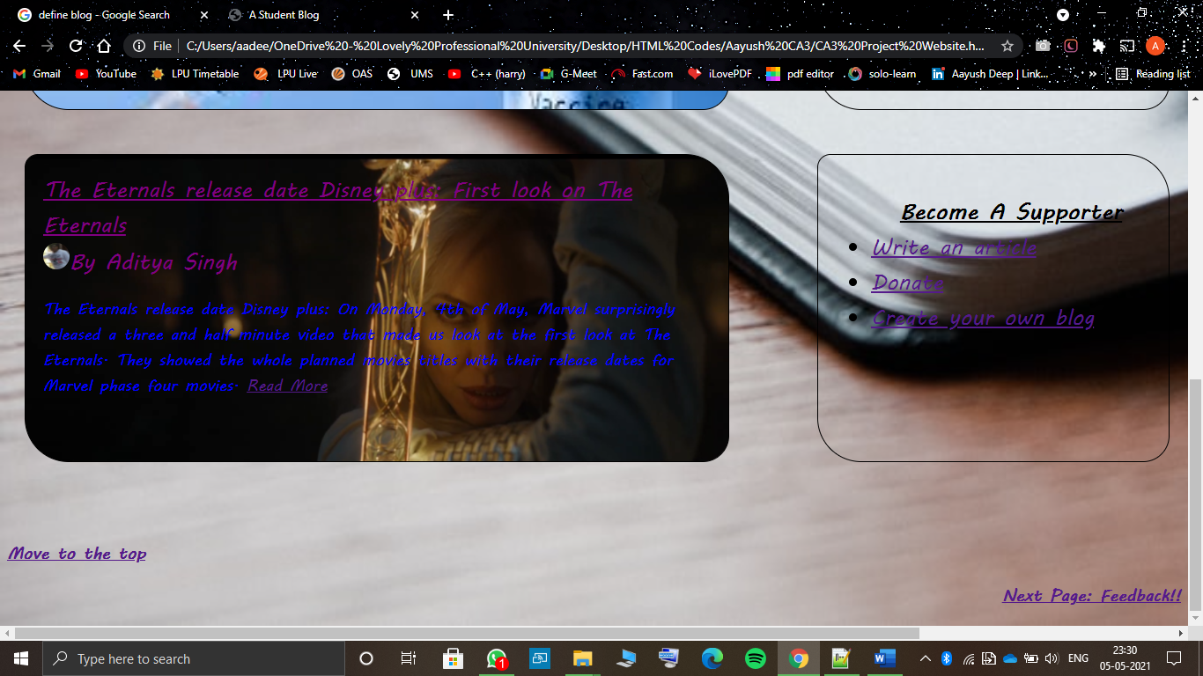

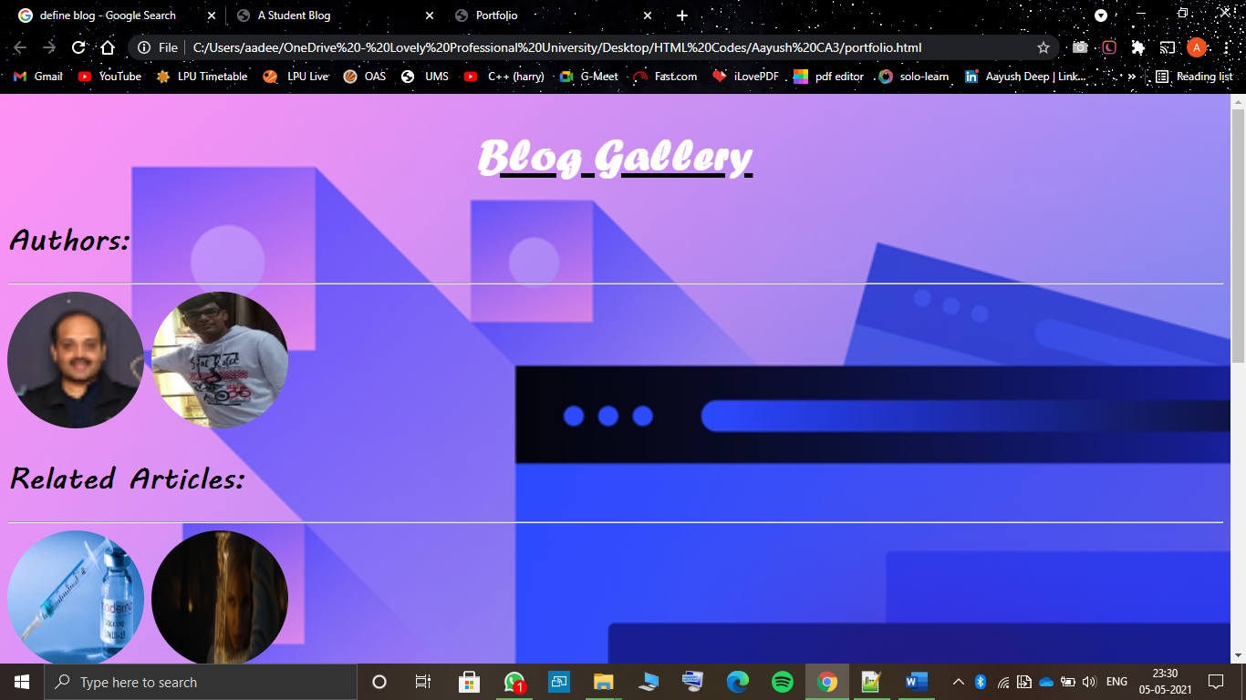

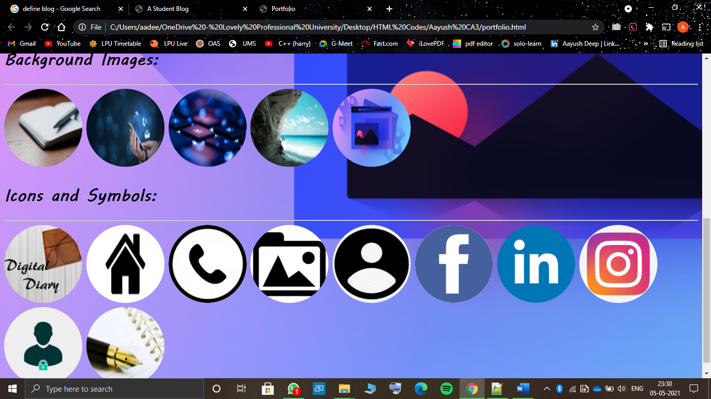

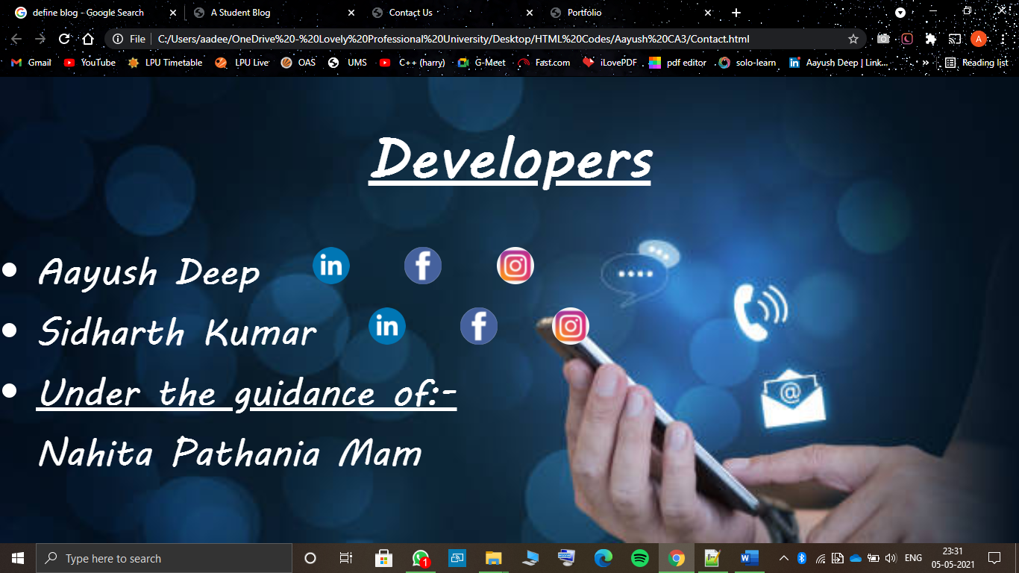

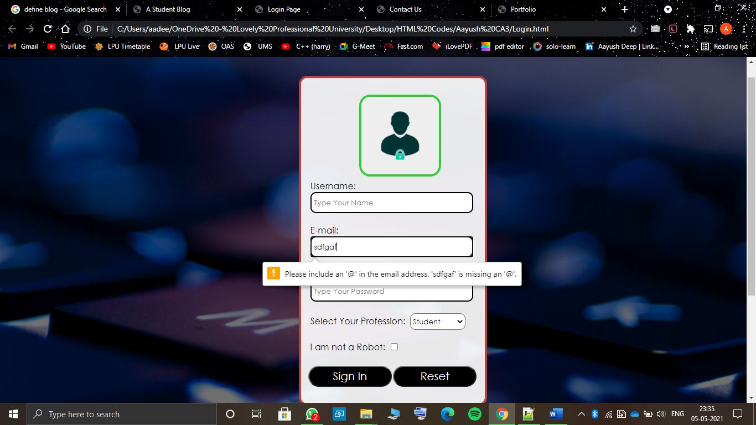

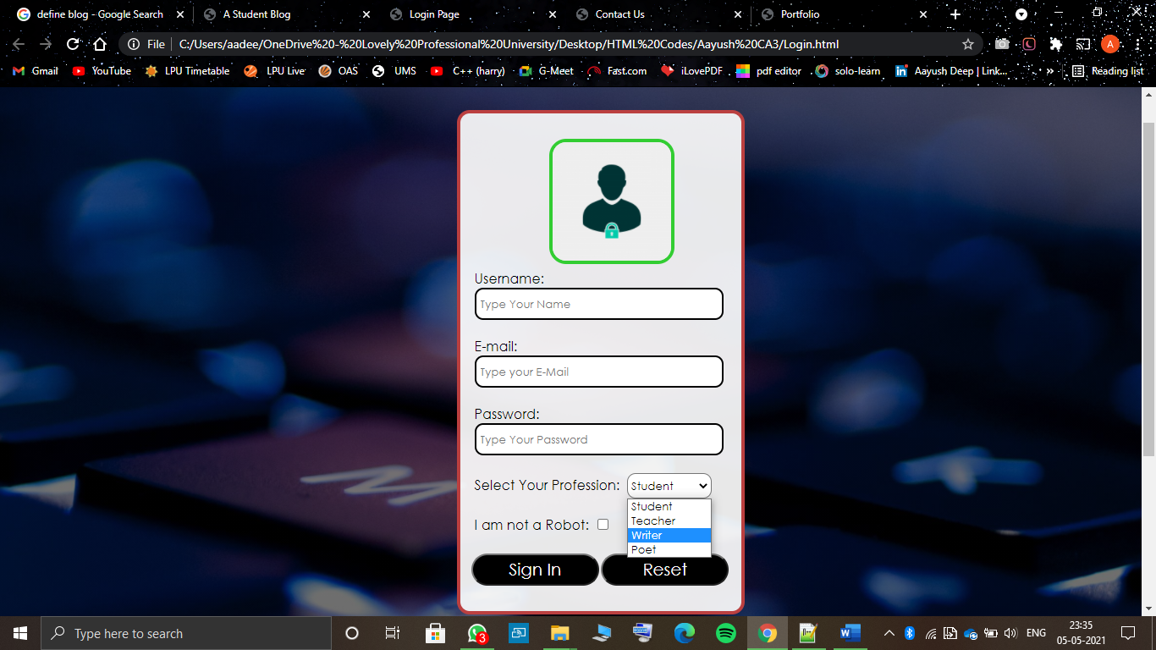

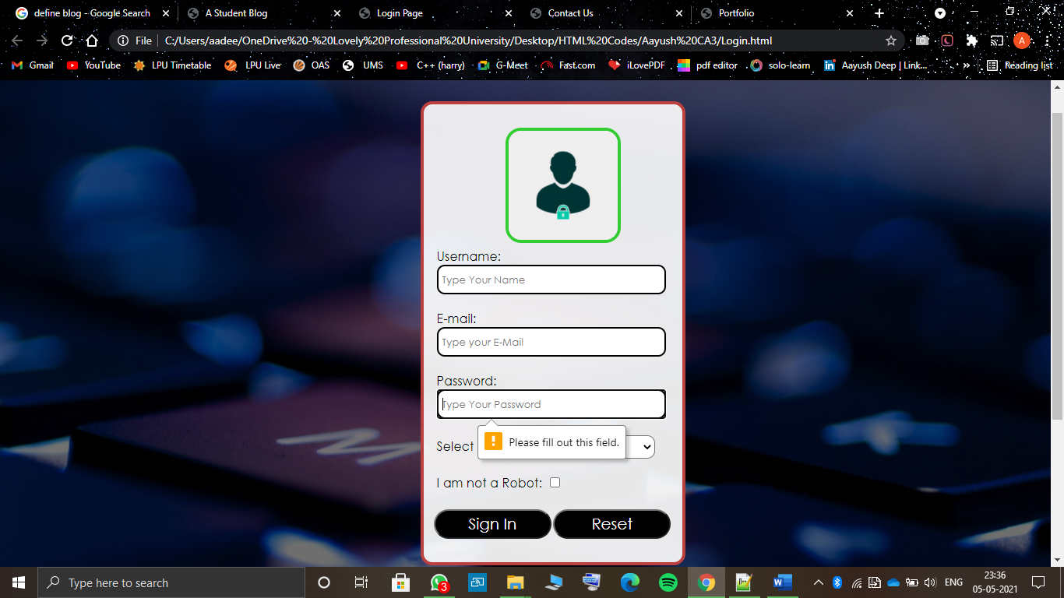

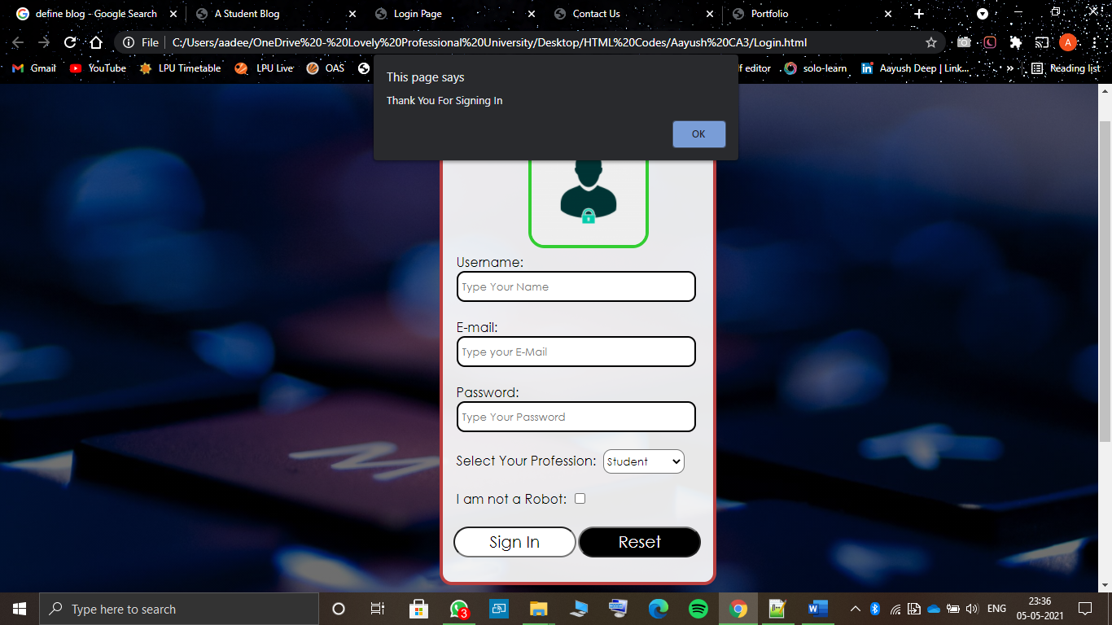

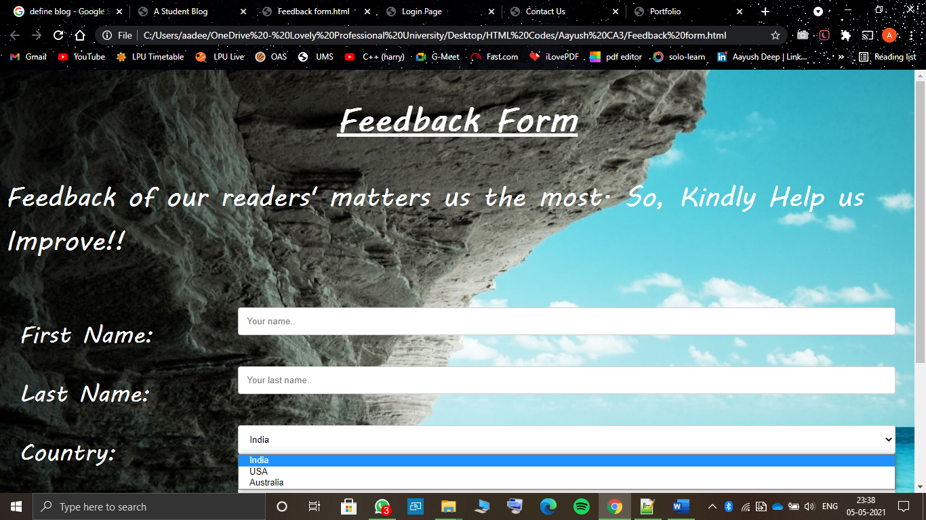

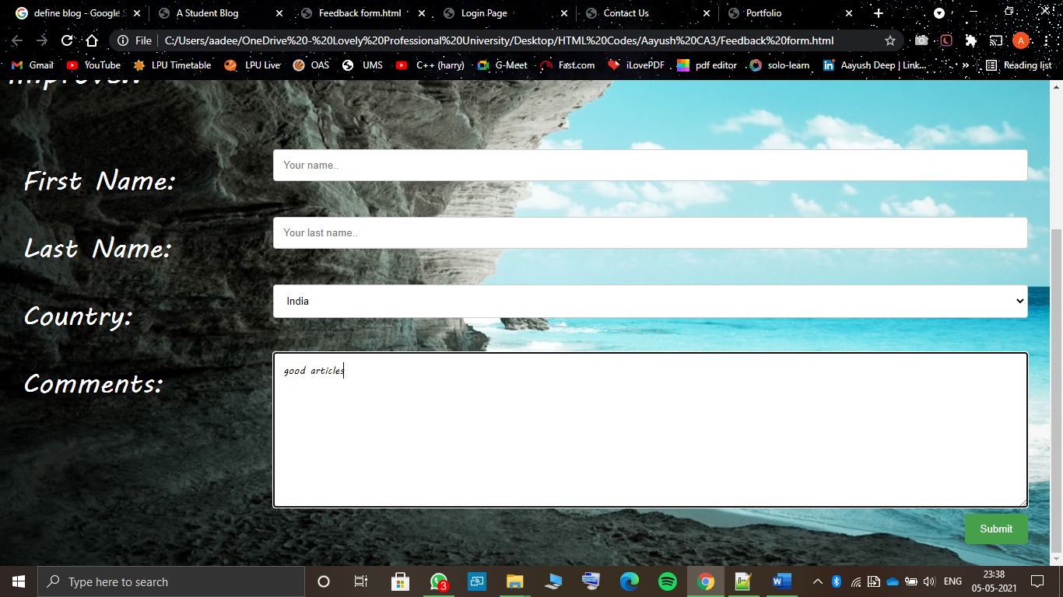

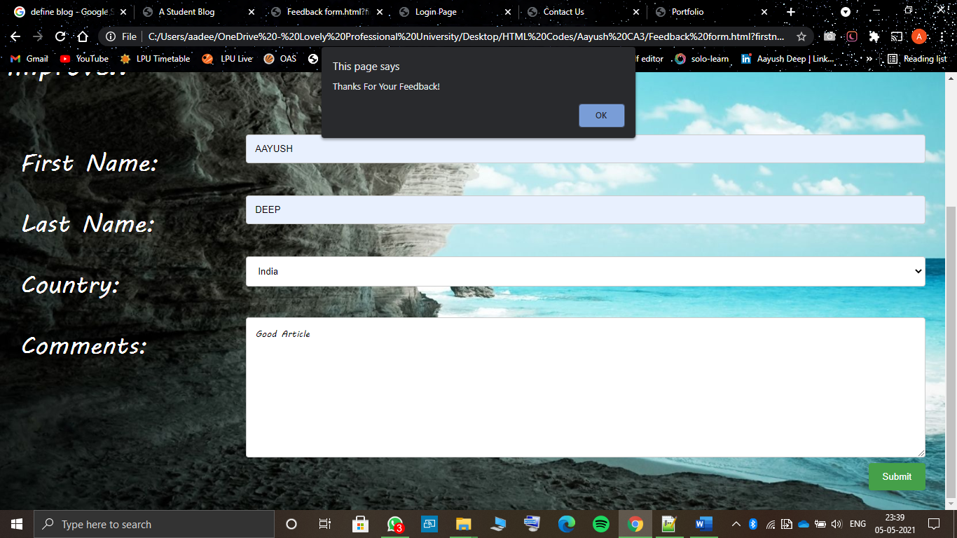

**Link for the website:-** <http://jaxerzr.me/aay/>

**THANK YOU**